South China University of Technology
《Computer Organization and Architecture》Experiment Report
Experiment Title： Serial Adder & Parallel Adder
Name： 林宇晟 Student ID： 202130430140
Class： 21计创 Group：
Collaborator：
Teacher： 毛爱华
Description
【Objective and Requirement】
Objective：
(1) Understand the sturcture of serial and parallel adder;
(2) Know the principle and implementation of arithmetic shift register;
Requirement：
Design 4-bit signed serial adder and parallel adder with same inputs, and compare the resuts of them.
【Environment】
Operating System：Windows 11
Content
【Procedure】
- Step：
Based on previous diagrams and principles, design the whole circuit diagram and verify the correctness.
Start the simulation, Switch SW2 to make (SW_BUS) ̅=0.
Let BUS_[7..4]=0101，BUS_[3..0]=0010(Set the input bits in DSW1)，M=0(switch SW7). Observe the result and compare it between serial and parallel adder, check if it’s overflow.
Do the same when
BUS_[7..4]=0101，BUS_[3..0]=0011，M=0
BUS_[7..4]=0101，BUS_[3..0]=0011，M=1
BUS_[7..4]=0011，BUS_[3..0]=0101，M=1
BUS_[7..4]=1101，BUS_[3..0]=0011，M=0
BUS_[7..4]=1101，BUS_[3..0]=0011，M=1

- Data：
BUS_[7..4]=0101，BUS_[3..0]=0010，M=0
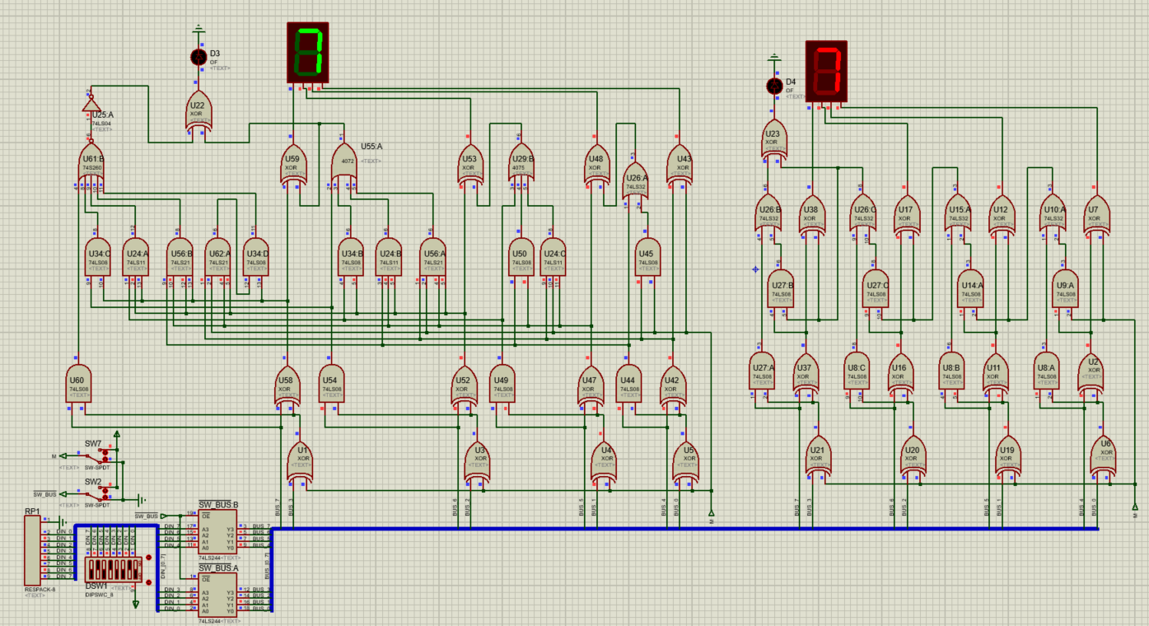
BUS_[7..4]=0101，BUS_[3..0]=0011，M=0
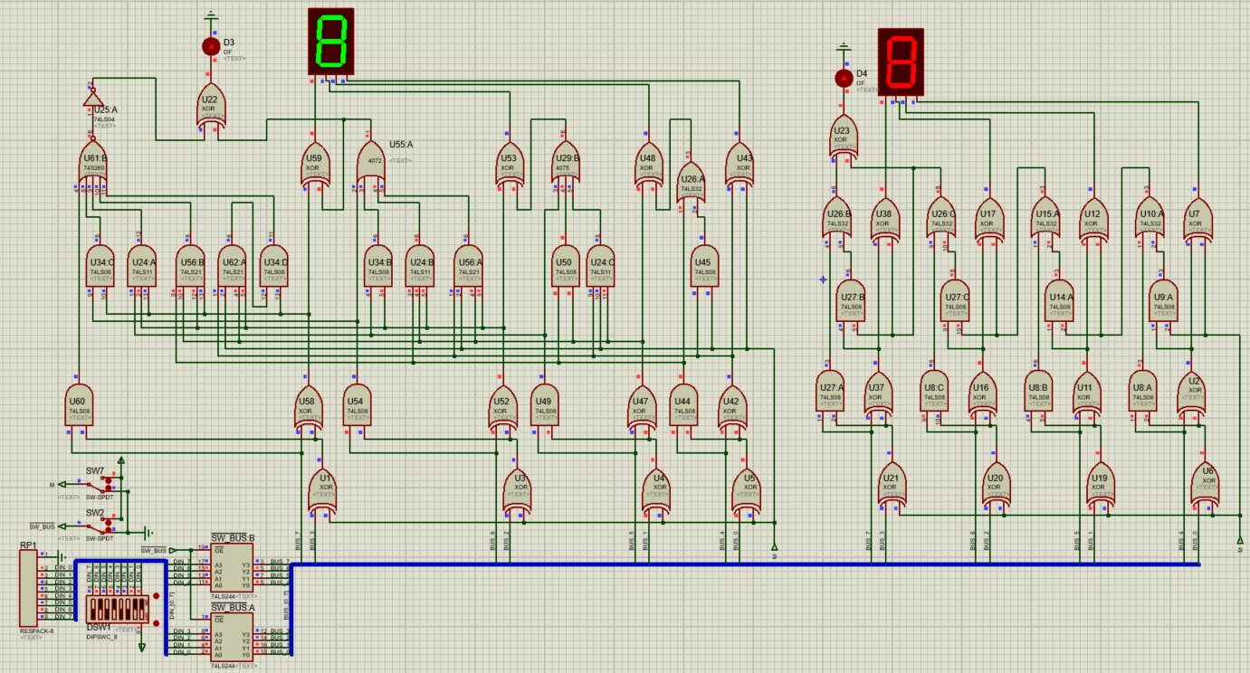
BUS_[7..4]=0101，BUS_[3..0]=0011，M=1
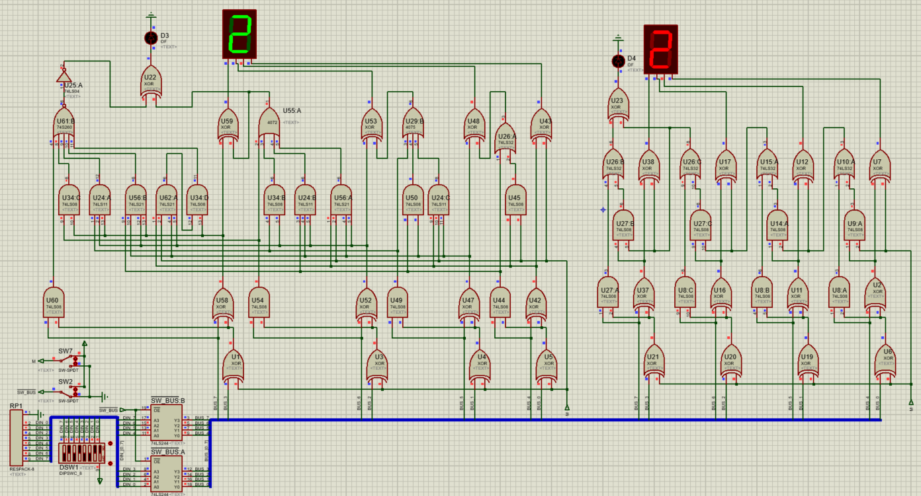
BUS_[7..4]=0011，BUS_[3..0]=0101，M=1
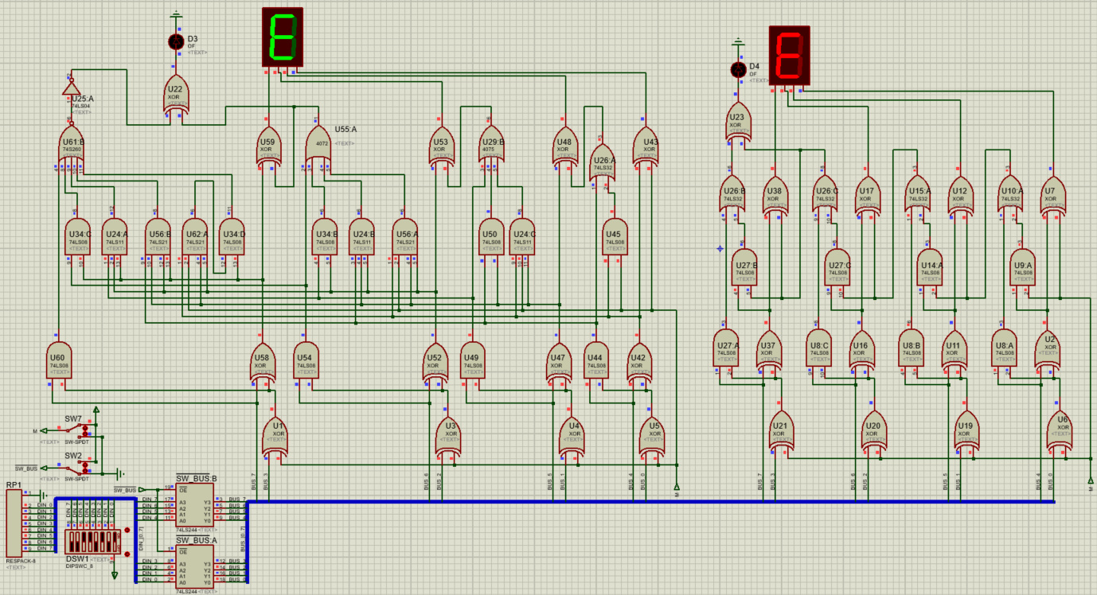
BUS_[7..4]=1101，BUS_[3..0]=0011，M=0
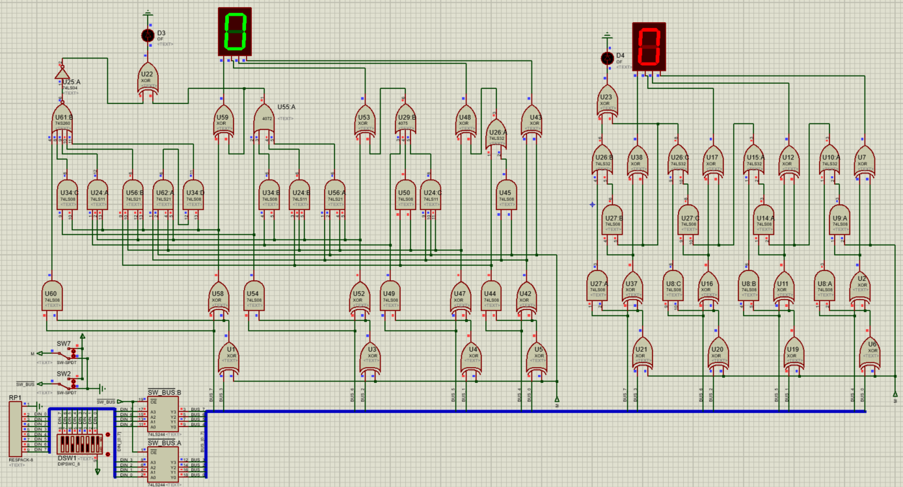
BUS_[7..4]=1101，BUS_[3..0]=0011，M=1
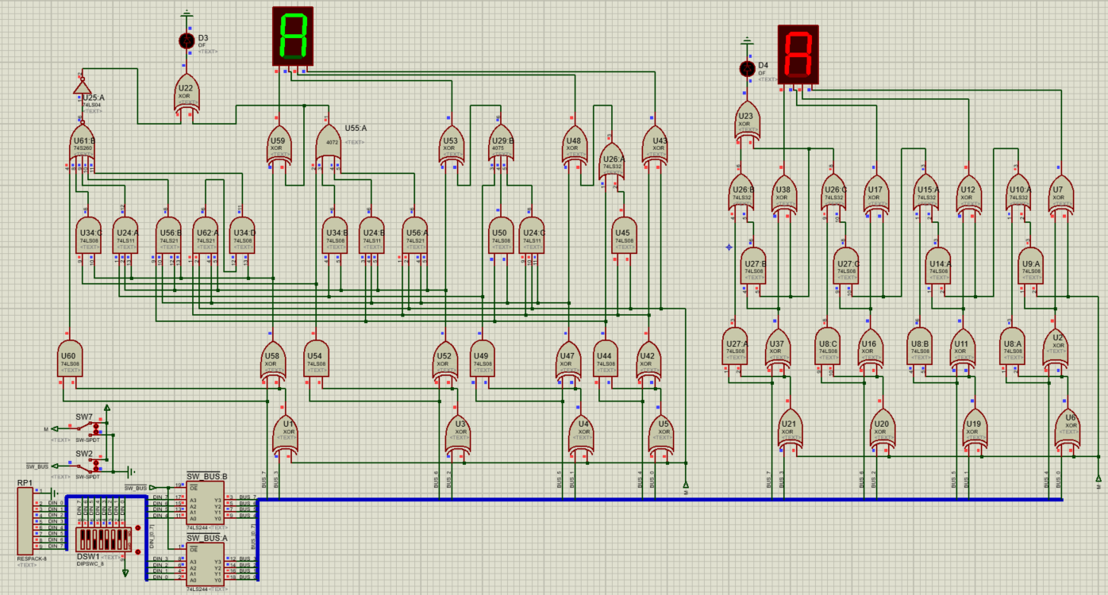

a.Is this experimental ALU original form or 2’s complement form? Assume we want to modify the circuit into unsigned 4-bit original form ALU, what we need to do?
ANS: It is in the 2s complements form. To modify to the unsigned int, we need to

b.In this experiment, what’s the range of the 4-bit 2’s complement code? If we want to modify it into 5-bit 2’s complement ALU(1 bit for sign bit, 4 bits for numbers), how does the range change? How to modify it?
ANS: The range is [-8, 7]. If change into 5 bit 2s complement, the range is [-16, 15]. For serial adder we need an extra line to represent the sign bit, for Parallel Adder, we need 5 extra lines to calculate the sign bit.

3. Major Procedure：

Conclusion
In this experiment we learn how to construct serial adder and parallel adder, also learn about the principle of 2 adders. Serial adder is calculate serial numbers one by one through the full adder, it has a low cost but the speed is slow. Therefore, multiple full adders are used as parallel adders, but there is also a problem in parallel. The adder needs to transmit the carry signal, which is a comparison delay time. So carry is divided into two kinds, one is serial carry, one is parallel carry.

Teacher’s Comments and Score
Comment：

Score： Signature：
Date：

